19 marzo 2018

Author: **Nick4Name di Nicola Martella & F. s.a.s**



|  |
| --- |
|  |
| B1InterSIV : SIV-SAP Business One Integration |
|  |
| Ver. 1.0 |

B1InterSIV : SIV-SAP Business One Integration

Ver. 1.0

# B1InterSIV suite

**B1InterSIV**is a suite of programs for the integration of accounting registrations from SIV to SAP Business One for the customer **StorGaz**.

# Components

With this build we release programs at following version:

|  |  |  |
| --- | --- | --- |
| **Component** | **Version** | **18/03/2018** |
| AbstractNET.dll | 1:2:5:0 | General library |
| B1LauncherJE.exe | 1.1.0.19310 | Application to import SIV accounting registrations in B1 |
| B1LauncherJE.exe.config | not versioned | Configuration file for B1LauncherJE.exe |
| CommonLib.dll | 1.3.0.39575 | General library |
| Configuration.gaz | 1.3 | Configuration repository for the solution |
| N4NLogService.dll | 1:1:2:20534 | Core library for log trace |
| N4NTraceOnFilePlugIn.dll | 1:0:3:20537 | Plugin to trace the activities in a flat file |
| SAPBusinessOneSDK.dll | 1:0:0:1 | SAP Business One Studio SDK |

# Prerequisites

The **B1InterSIV**suite requires .NET Framework 4.7 or early.

<https://www.microsoft.com/en-us/download/details.aspx?id=56116>

Furthermore, are required on the B1InterSIV client SAP Business One Data Interface SDK version **9.20.190** or early and **SAP B1Studio** compliant to DI-API version.

# Deploy

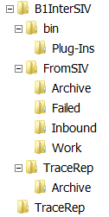

This version is tested and released for Microsoft SQL Server 2014.

To setup *B1InterSIV* is enough unzip **B1InterSiv_v1.0_binary.zip** under a root directory to get the branch of path in Figura 1.

Under **bin** directory are installed B1InterSiv programs excepted for *N4NTraceOnFilePlugIn.dll* that is installed under **Plug-Ins** directory.

**FromSIV** path is the root for files from SIV. The **Inbound** directory corresponds to the FTP folder reached from SIV to upload the files. The uploaded files are processed from the applications starting on **Work** directory.

Figura 1 – B1InterSIV

file system

The SIV file moving from **Inbound** folder to **Work** folder is not provided from B1InterSiv and needs of an external process, batch script or other.

The files successfully processed are automatically moved under **Archive** directoryand renamed with a timestamp. The processed files in error can be moved under **Failed** directory if enabled in *Configuration.gaz* setup. **Archive** and **Failed** directories are automatically created if missing.

The **TraceRep** directory is the root for the trace log files. When a log file grows over the desired dimension, it is automatically stored under the **Archive** sub directory.

# B1InterSiv Configuration

The configuration file **B1LauncherJE.config** refers the B1InterSiv general setup file **Configuration.gaz** that can be in the same or different directory, Figura 2.

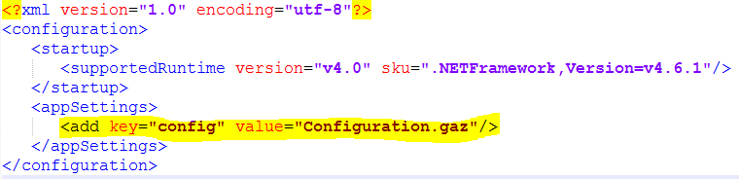

Figura 2 - B1LauncherJE configuration file

The *Configuration.gaz* is the global B1InterSiv configuration repository.

Figura 3 - Configuration.gaz: configuration repository

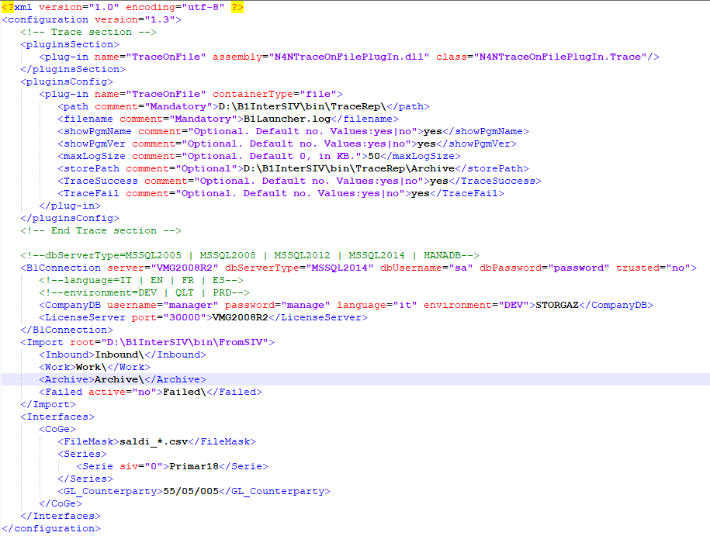

The sections **pluginsSection** and **pluginsConfig** are referred to the plugin programs to trace the activities into log repositories.

The **pluginsConfig/plug-in/path** and **storePath**, according to the file system in Figura 1, pointing the directories for log file, named in **filename** parameter, and its archiving path when it reaches the dimension setted in **maxLogSize** parameter.

The parameters **TraceSuccess** and **TraceFail** filtering the activities to log basing of their severity. If you want to see in the log the *info* severity activities you set *TraceSuccess=yes* otherwise *no*. In the same way, if you want to track the *warning* and *critical* activities set *TraceFail=yes*.

In **B1Connection** section you have the parameters to log on the SAP B1 database, company and License Server.

Pay attention that the passwords setted into the *Configuration.gaz* file are in clear.

The **Import** section describes the operative directories according to filesystem described above. The **root** parameter is the absolute directory and the other parameters are related to it.

At the **Interfaces**/**CoGe** section, is referring the **B1LauncherJE** program.

In **FileMask** element is setted the file mask for the inbound files from SIV.

In **GL_Counterparty** element is setted the counterparty account that balances registrations from the file, see *Journal Entry file structure* paragraph.

In the **Series** subsectioncan be addedas many **Serie** sections as many are the SIV series. For each SIV serie, **siv** attribute, one B1 serie has be indicated. In the next example, the SIV serie “**0**” is coupled at the “**Primar18**” B1 serie.

<CoGe>

<FileMask>saldi_*.csv</FileMask>

<Series>

<Serie siv="0">Primar18</Serie>

</Series>

<GL_Counterparty>55/05/005</GL_Counterparty>

</CoGe>

Thanks to this, SIV can sent items for several its series and for each ones is coupleble one in B1

<Series>

<Serie siv="0">Primar18</Serie>

<Serie siv="1">Primar18A</Serie>

<Serie siv="2">Primar18B</Serie>

</Series>

# B1 Configuration

# To set in @SYS_GAZ_OADM table the kind of environment: DEV, QLT or PRD.

# Operations

The operations are carried out by the *B1LauncherJE* program that must be scheduled according to SIV sending.

The first time that B1LauncherJE is executed, after setup, it’s need to run it with administrative rights because a new event log is created in *Event Viewer*. If you forget this, the following exception will be raised

Seleziona C:\Windows\system32\cmd.exe 
C : \bin>B1 LauncherBP . exe 
Eccezione non gestita: System. Security. SecurityException: Origine non trovata, ma non è stato possibile eseguire 1a rice 
rca in uno o più 109 eventi. Log non accessibili: Security. 
in BI LauncherBusinessPartners . Application.uriteSystemEuentL09(SystemEuentErrorLeue1 leuel , 
Int6Ll errCode, String errM 
in BI LauncherBusinessPartners.Modu1eB1 args) 

Figura 4 - Exception raised for administrative rigths missing

After this unique time, you can run the program with normal user rights.

# Track activities in log

The activities are tracked in two kinds of logs. The preliminary activities are tracked as *Windows Administrative Events* and you can view them by the *Windows Event Viewer*. All the other activities are tracked into the log file referred by the *Configuration.gaz*.

In *Windows Administrative Events* will be created a new *B1LauncherJE* event log. One of these is showed below

Visualizzatore eventi 
File Azione Visualizza ? 
Visualizzatore evenb (computer locale) 
Visualizzatore eventi (computer locale) 
Panoramica e riepilogo 
Nome registro 
Applicazione 
BILauncherBP 
Eventi hardware 
Internet Explorer 
Key Management Service 
Media Center 
Microsoft Office Alerts 
PreEmptive 
Si curezza 
Sistema 
Ultimo a 
ornamento: 21 11 2016 
Dimensione (co... 
107 MB/20 MB 
68 KB/LOO MB 
68 KB/20 MB 
68 KB/LOO MB 
68 KB/20 MB 
68 KB/8 MB 
68 KB/LOO MB 
68 KB/LOO MB 
107 MB/20 MB 
107 MB/20 MB 
Ultima modifica 
20/11/2016 
21/11/2016 
27/10/2016 
27/10/2016 
27/10/2016 
27/10/2016 
27/10/2016 
27/10/2016 
20/11/2016 
20/11/2016 
Attivato 
Attivato 
Attivato 
Attivato 
Attivato 
Attivato 
Attivato 
Attivato 
Attivato 
Attivato 
Attivato 
Criteri di gestione 
Sovrascrivi 
Sovrascrivi 
Sovrascrivi 
Sovrascrivi 
Sovrascrivi 
Sovrascrivi 
Sovrascrivi 
Sovrascrivi 
Sovrascrivi 
Sovrascrivi 
eventi s 
eventi s 
eventi s 
eventi s 
eventi s 
eventi s 
eventi s 
eventi s 
eventi s 
eventi s 

Figura 5 - Event registry for the program B1LauncherBP

If the program’s startup is without errors, the entries in this log will be the following:

|  |  |
| --- | --- |
| *** Start customer import process *** | Startup for the import process |
| Configuration repository: C:\MyPrograms\StoreGaz\Configuration.gaz | Link of the configuration repository |
| From now, follow customer import activity on C:\MyPrograms\StoreGaz\TraceRep\B1Launcher.log. | Notification for the file log in which the next activities will be tracked. |
| Required connection to company STORGAZ for develop environment. | Declares company connected and its type of environment |

The file **B1Launcher.log** is unique for all the import interface programs.